**Metaphor/Architecture Specification Template**

|  |  |  |  |  |
| --- | --- | --- | --- | --- |
| Student | Javier Mesa | | Date | 09/04/2017 |
| Program | PSP2.1 | Program # | 6 | |
| Instructor | Mario Riveros | Language | Java | |

|  |  |
| --- | --- |
| **Design**  **References** | Functional Specification |
| Operational Scenarios |
| State Specification |
|  |  |
|  |  |

**Graphical representation of the metaphor**

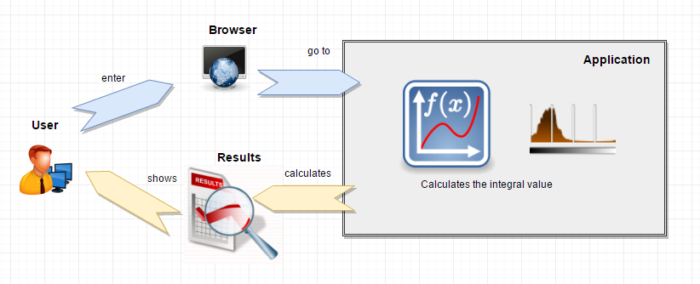

**Textual representation of metaphor**

The user enters opens a window of his preferred browser, and writes the URL of the application, enters the parameters of ***p*** and ***dof***. The application makes the necessary calculations and prints on the page the expected value for the values you enter and the user is happy with the result.